**Faculty of Computing & Information Technology**

**INDUS UNIVERSITY**



**“Artificial Intelligence (Lab)”**

**(0+1)**

**-------------------------------------------------------**

**Project Report**

**Title:**

**“Searches Using Several AI Algorithms”**

**-------------------------------------------------------**

|  |  |
| --- | --- |
| **Student Name** | **Student ID** |
| Abdul Basit Khan | 2551 – 2018 |
| Mubashir Qamar | 2356 – 2018 |

**Submitted to: Sir Abid Ali**

**ACKNOWLEDGMENT**

We are really grateful because we managed to complete our E-project within the time given by our teacher **Sir Abid Ali**. This assignment cannot be completed without the effort and co-operation from our group members, Group members; **Abdul Basit Khan** and **Mubashir Qamar.**

We also sincerely thank our teacher **Sir Abid Ali** for the guidance and encouragement in finishing this project and also for teaching us in this course.

Last but not the least, we would like to express our gratitude to our friends and respondents for the support and willingness directly or indirectly to spend some times with us to fill in the questionnaires.

**Table of Contents**

**1-** **Introduction** 4

**2-** **Objectives of the Project** 5

**3-** **Topic of our Project** 5

**4-** **Problem Statement** 5

**5-** **Hardware/Software Requirements** 6

**5.1- Hardware Requirements** 6

**5.2- Software Requirements** 6

**6-** **Work Analysis** 6

**7-** **Code Snippets** 7

**7.1-** **Main.py** 7

**7.2-** **Node.py** 10

**7.3-** **PriorityQueue.py** 10

**7.4-** **SearchAgent.py** 11

**7.5-** **Index.html** 15

**7.6-** **Style.css** 17

**8-** **Result/Output** 18

**9-** **Conclusion** 20

# **Introduction**

In Artificial Intelligence, Search techniques are universal problem-solving methods. Rational agents or Problem-solving agents in AI mostly used these search strategies or algorithms to solve a specific problem and provide the best result. Problem-solving agents are the goal-based agents and use atomic representation.

Searching problems can be solved using trees and graphs and to be be specific, trees and graphs works differently. For graphs, they are considered to be more accurate in searches but they can either be directed or undirected. Directed means that they contain a specific direction for the search flow whereas undirected does not have any direction which means the graph can go either way.

Generally, searches are of two types; the uninformed search (blind search) and the informed search. These searches works differently depending on the method chosen like blind search with Breadth-first search will work differently as compared to informed search with Depth-first search. Uninformed search will take a bit more time to reach to the goal node compared to the informed search as it takes a fairly lesser time but if we have opted for A* algorithm then we cannot say much on the time taken as these methods involves weights of the edge and the heuristics associated with them so time can vary.

There are two categories for graphs to be drawn:

* The Directed Search
* The Undirected Search

The two kinds of searches are as follows:

* The Informed Search
* The Uninformed Search (Blind Search)

Search techniques inside uninformed search are:

* Breadth-First Search
* Depth-First Search
* Depth Limit Search
* Iterative Deepening Search
* Uniform Cost Search

Search techniques inside informed search are:

* Greedy Search
* A* Search

# **Objectives of the Project**

The objective of this project is to make a problem-solving agent that can perform various searches using some AI techniques. Problem-solving, at times, can be difficult because the user will be willing to get as much efficiency as he can get, therefore this model will be providing us with several search techniques based on different kinds of problem.

Moreover, this project is useful to study different AI algorithms and to have a good hand on them as it enables us to choose nodes (initial node or the goal node) by ourselves in order to recognize how searches are being performed based on different techniques.

Furthermore, the goal is to have an understanding on the problems which involves several heuristics as they are the complex ones, but this agent is actually useful here as it provides us the way to choose the branching factor, heuristic value and the edges by ourselves so that we can find a way about how the searches are actually being done.

# **Topic of our Project**

The topic of our project is “Searches using several AI Algorithms”. Basically, this project is totally about searches and different techniques to be used in searches.

# **Problem Statement**

* Searching problems are becoming more complex
* No such problem-solving agent to deal with problems involving heuristics
* Fewer AI models with uninformed search techniques as they consume some time to get to the solution

# **Hardware/Software Requirements**

## **5.1- Hardware Requirements**

* A Computer System
* 2 GB RAM or above

## **5.2- Software Requirements**

* Visual Studio Code (Extensions: live server, code runner and python)
* Any Browser (Google Chrome and Microsoft Edge etc.)

# **Work Analysis**

|  |  |  |
| --- | --- | --- |
| **Tasks** | **Abdul Basit Khan** | **Mubashir Qamar** |
| **Analysis** |  |  |
| **Design** |  |  |
| **Coding** |  |  |
| **Testing** |  |  |
| **Documentation** |  |  |

# **Code Snippets**

## **Main.py**

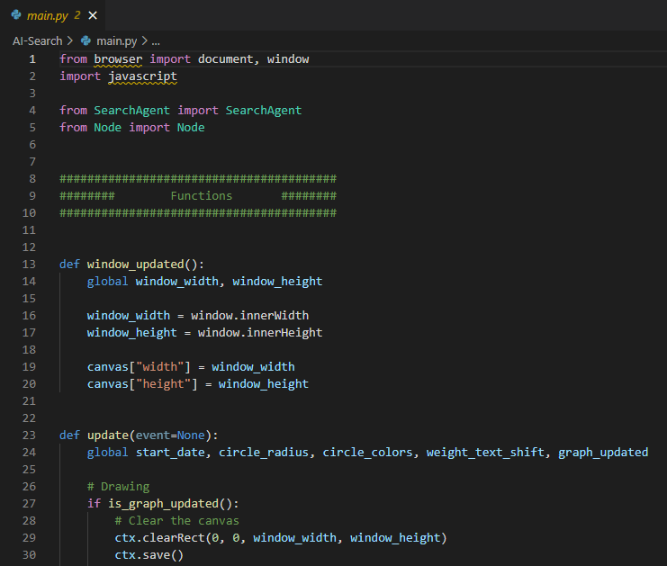

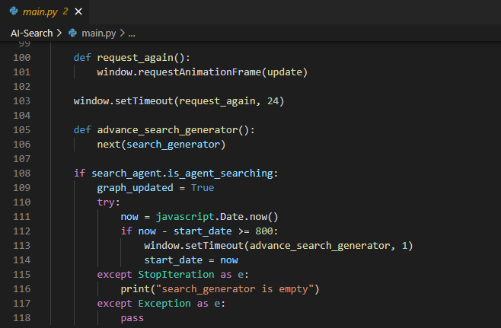

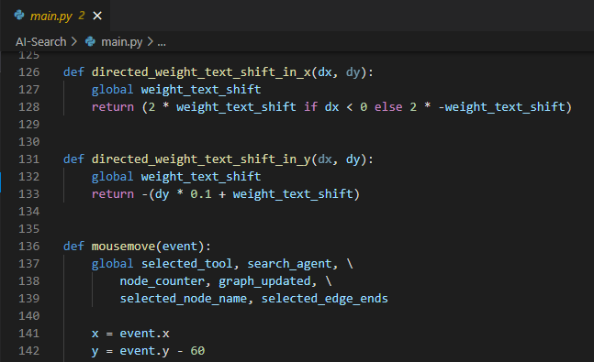

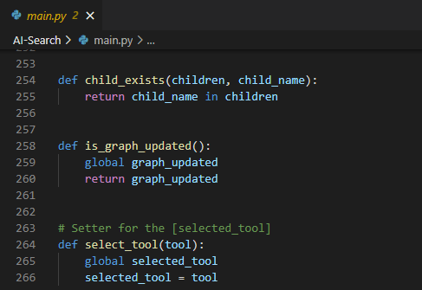

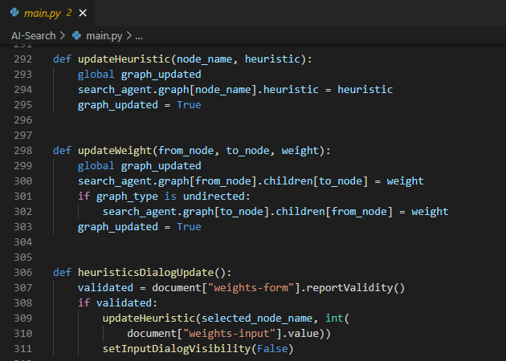

## **Node.py**

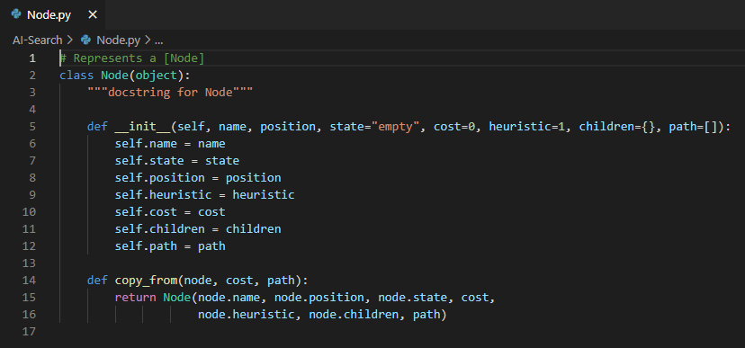

## **PriorityQueue.py**

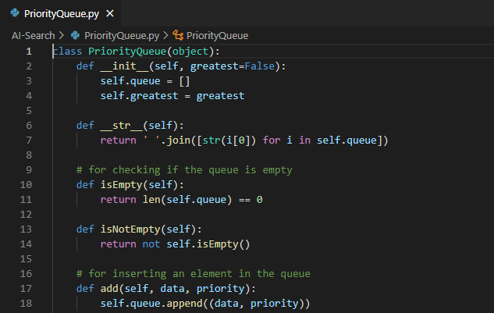

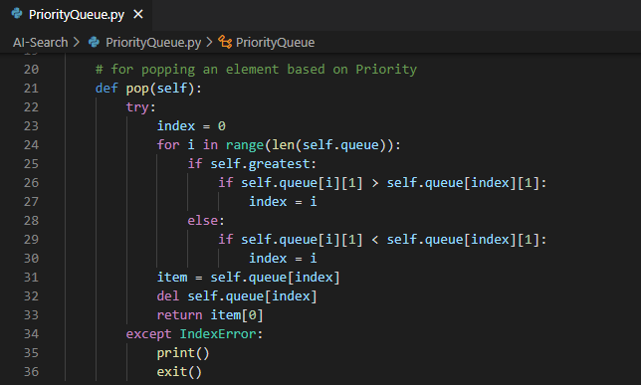

## **SearchAgent.py**

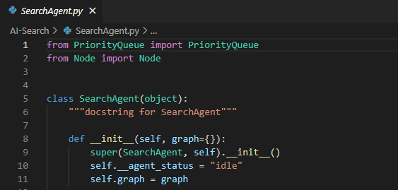

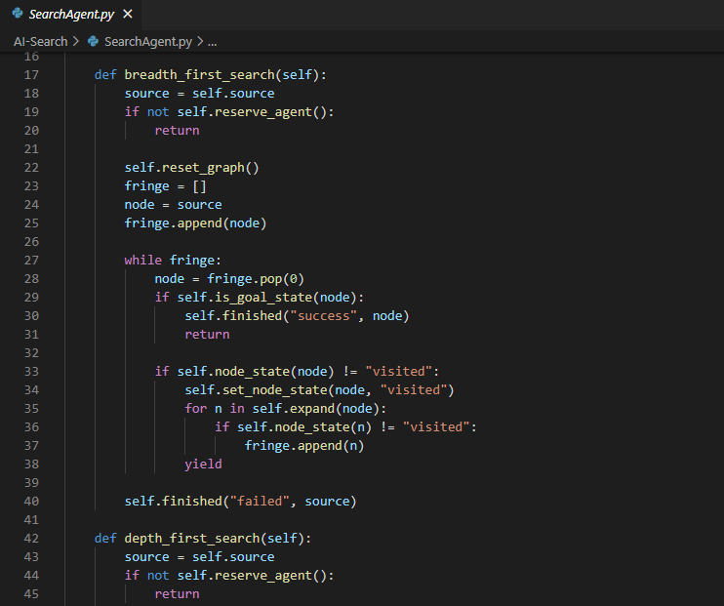

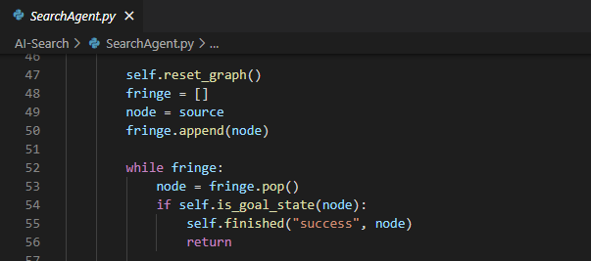

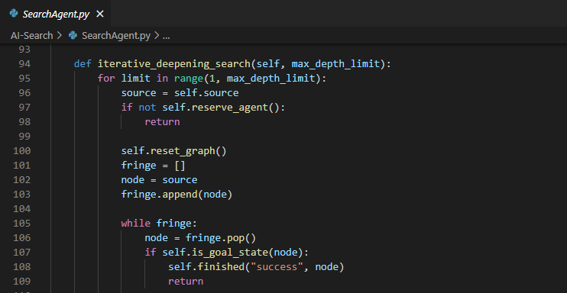

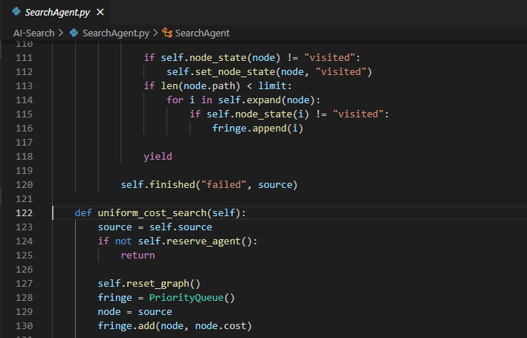

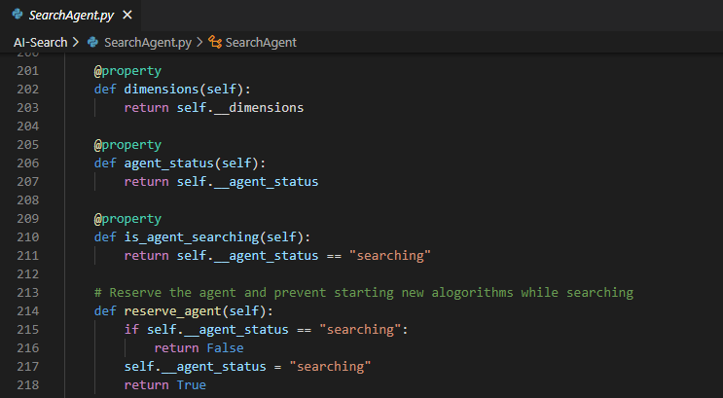

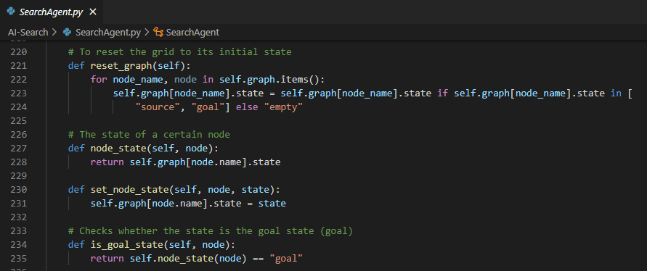

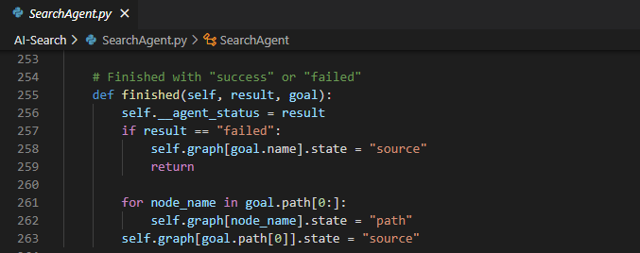

## **Index.html**

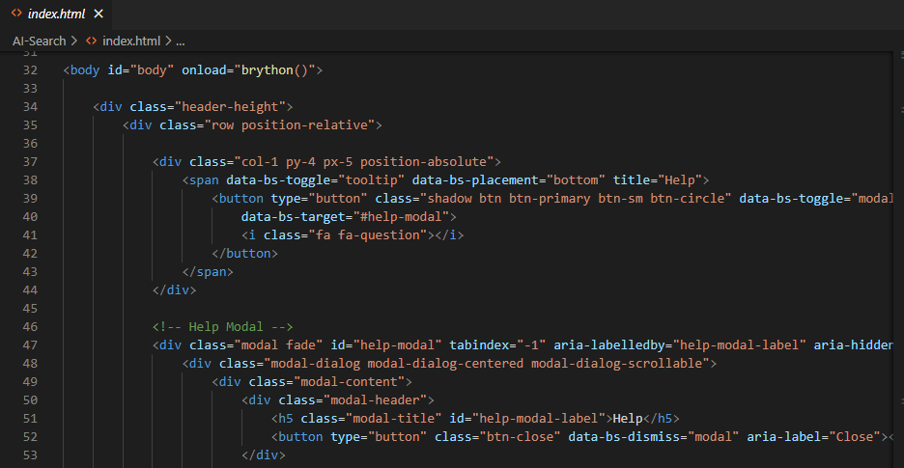

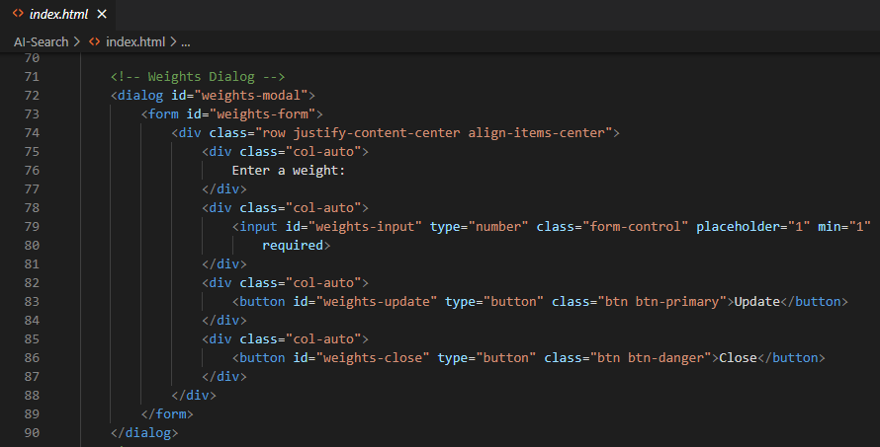

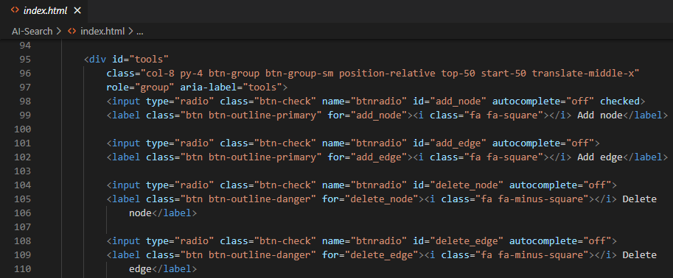

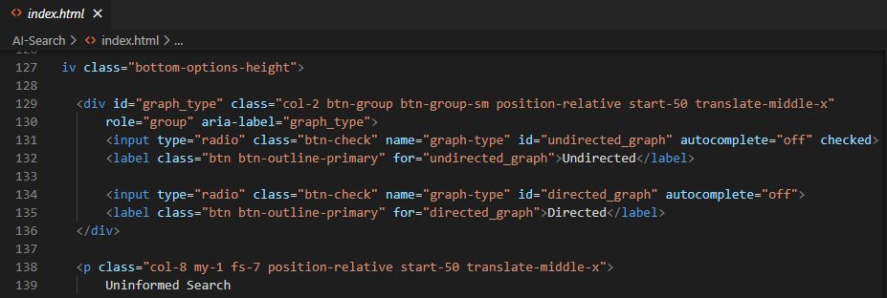

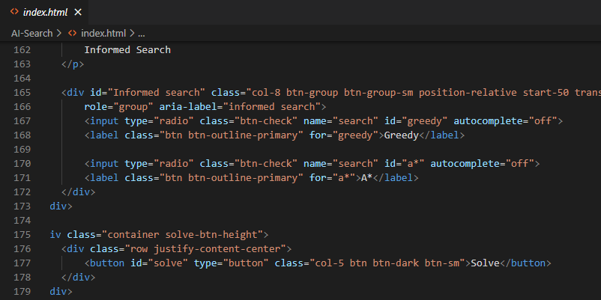

## **Style.css**

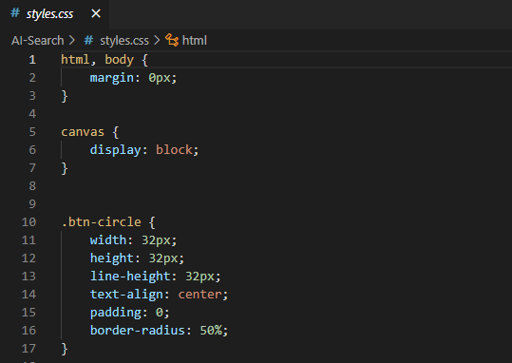

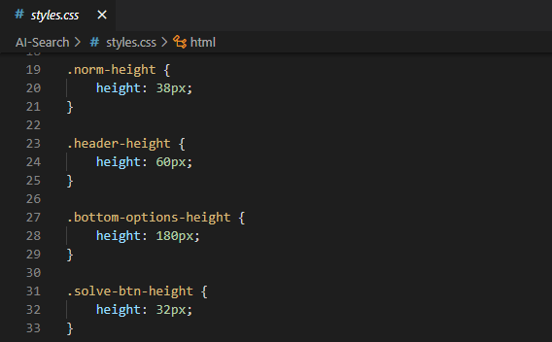

# **Result/Output**

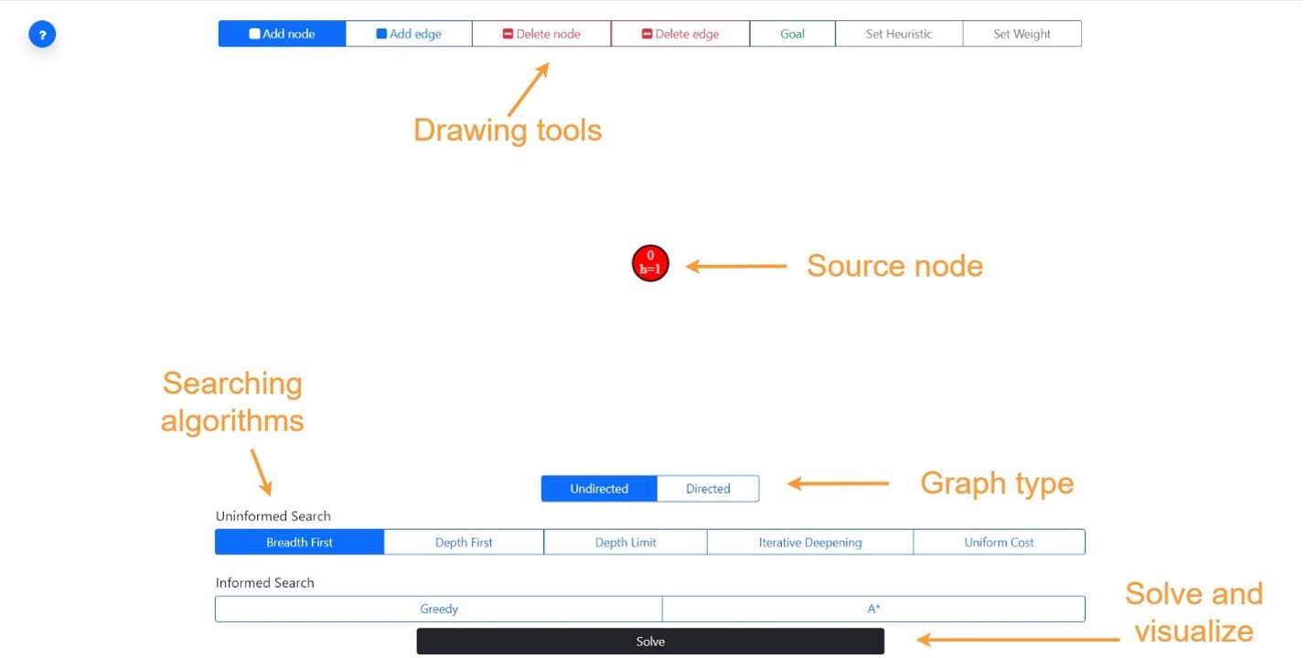

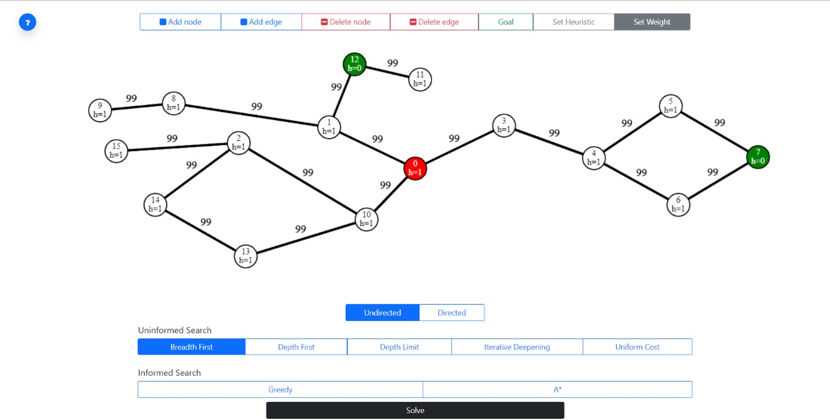

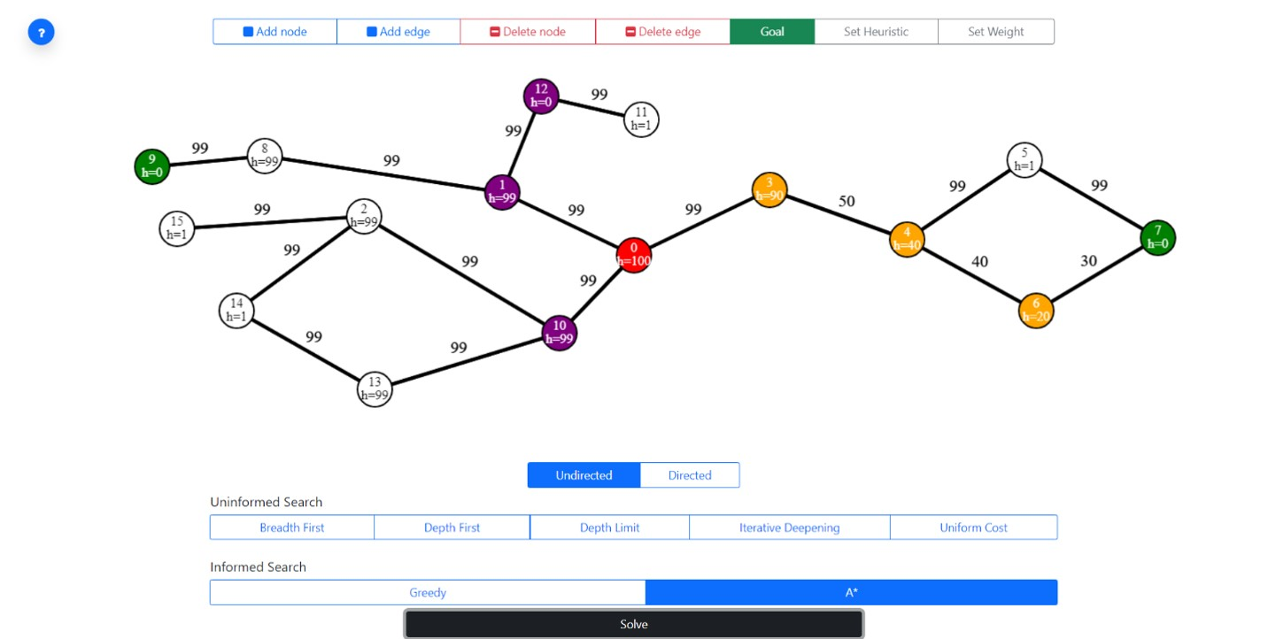

# **Conclusion**

Since, we know that searches are a common task these days and it is to be done efficiently in order to achieve a wholesome output. Searches in Artificial Intelligence corresponds the nature of work like it can done in many ways but the target is to choose the path which takes us to the goal. Goal state can be reached in many ways but the challenge is to pick up the most appropriate algorithm.

However, we know the difference between LIFO (Stack) and FIFO (Queue) and these terms are essential in implementing the algorithms because it depends on the requirements of the problem. For instance, if we are using the Breadth-First Search (BFS) technique then the entire algorithm is to be based on the technique involved in LIFO (Stack) and vice versa with FIFO (Queue).

* Basic and complex searching problems are now easy
* Problem solving agent must be the rational
* Uninformed searches take a bit more time as compared to informed searches
* Uninformed searches have information of the goal node
* Directed graphs can go either way whereas undirected graphs have only one direction
* A* search method is the efficient one among all if branching factor is to be taken into consideration